MSIS 638

Jia Liang Ma

Case 3.3aiii

1. If the minimum acidity requirement increases from 5.50 to 5.51, how would this change impact the optimal total cost? What if minimum requirement changes from 5.5 to 6?
2. For the change in acidity requirement, 0.01 does not do any impact on the change of optimal total cost.
3. For the change in acidity requirement to 6, the solver shows unable to find the optimal solution for total cost.
4. If the minimum bitterness requirement increases from 7 to 9, how would this change impact the optimal solution? What if it changes from 7 to 6.5?
5. None change. For changing the bitterness requirement from 7 to 9 will cause the error in solver for finding the optimal solution.
6. In answer report, the 7 bitterness is not binding with the status and its slack is 2.5. However, after adjusting the value to 6.5, the status become binding, and the slack become 0. This shows that with the lower value in bitterness, the constraints will be more related to the solution.

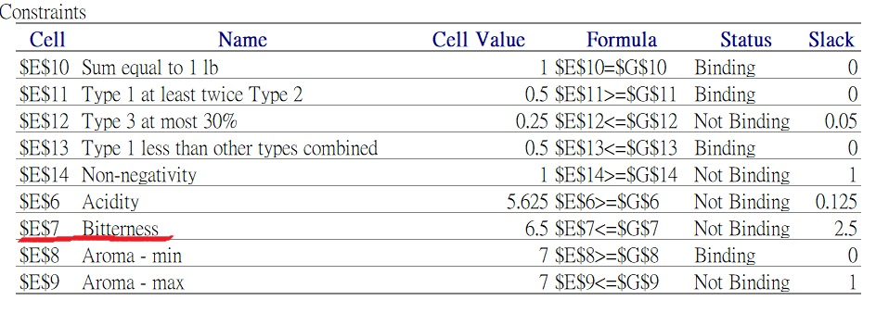

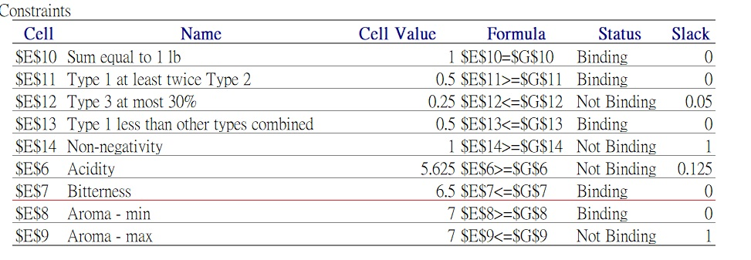

1. If the minimum requirement for aroma rating changes to 6.9, how would this change impact the optimal total cost?

The total cost has been reduced from 1.08 to 1.07 since the minimum of aroma rating changing to 6.9.

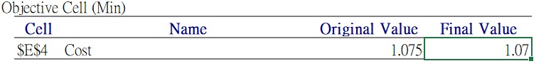

1. How much the maximum requirement for aroma rating can decrease before the current solution is no longer optimal?

The value decreasing for no longer an optimal solution of maximum for aroma is 1.1. The solver will cause an error when decreasing over 1.1 on maximum of aroma. For decreasing at 1 point, the status will become binding. As the figure shows below:

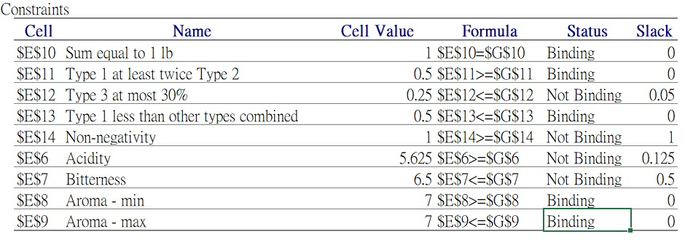

1. The supplier has decided to increase the price of Type1 to $1.05. Would this change impact the current optimal combination of the three types? Would this change impact the optimal total cost?

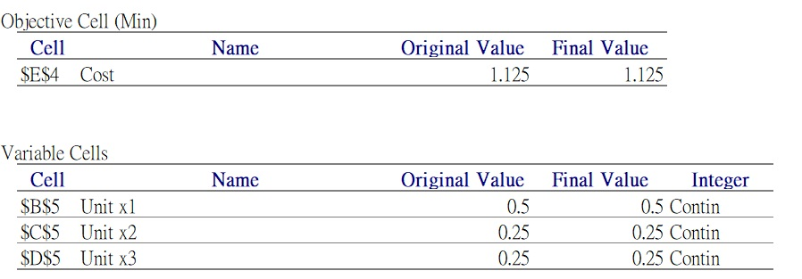

As the figure shows above, after changing the Type 1 to $1.05, the combination of three types does not change. For the final optima total cost, it changed from 1.08 to 1.125 (total increased 0.45)

1. If the supplier is willing to provide type 1 for free, would it impact the optimal combination?

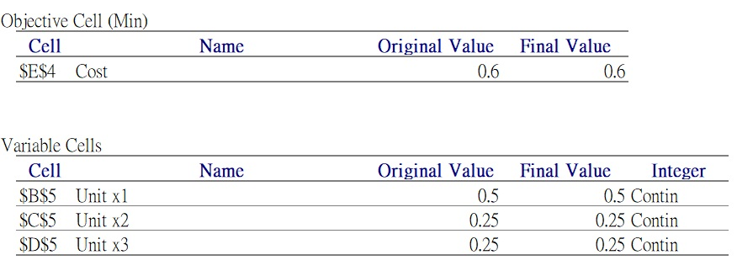

As the figure shows above, if Type 1 for free, it changes nothing in combination but in its optimal total cost.

The combination is still 0.5, 0.25, 0.25.

The total cost become 0.6

1. The supplier has decided to increase the price of one of the types by $0.1. The manufacturer can choose which type is going to be more expensive. Which type the manufacturer should choose?

Type1 increased by $0.1: $1.05

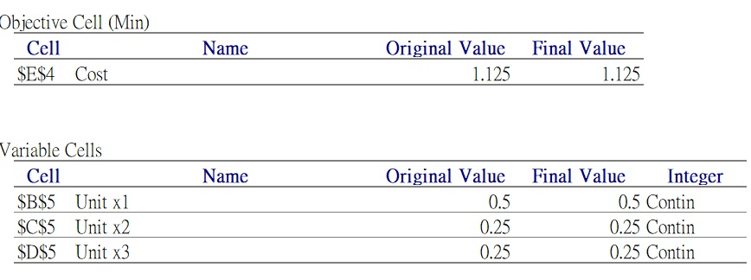

Type 2 increased by $0.1: $1.35

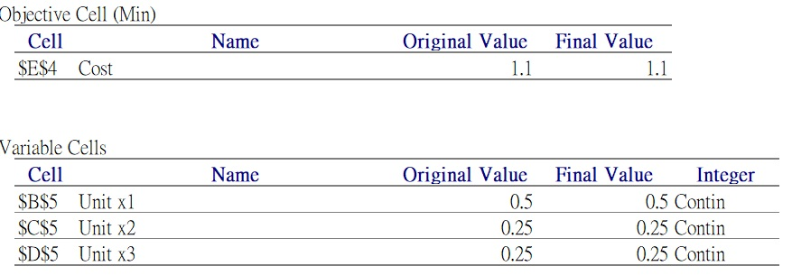

Type 3 increased by $0.1: $1.25



After testing three different cost changing, the optimal choices for manufacturer to add cost are type 2 or type 3 because of lower total cost.